28.73:

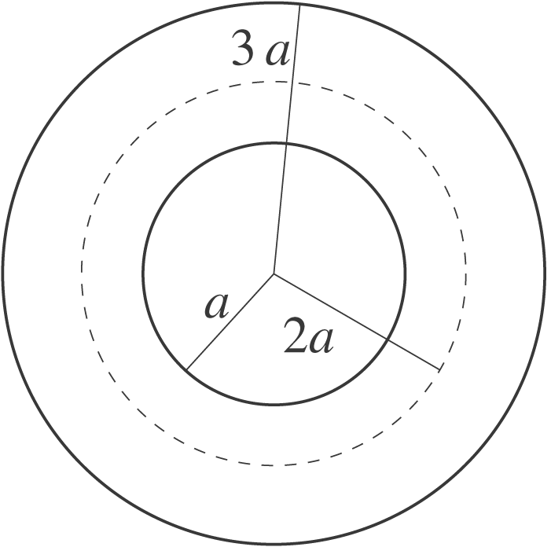 Apply Ampere’s law to a circular path of radius 2a.
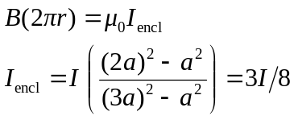
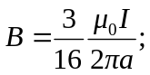 this is the magnetic field inside the metal at a distance of 2a from the cylinder axis.
Outside the cylinder, 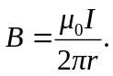 The value of r where these two fields are equal is given by 